# COMP1003 Maths Worksheet 2

1. A := { (-x)2 : x in **Z** } = ? [list the first 5 smallest elements only ]
2. { -x : x in A / { 2y + 1 : y in **Z** } } = ? [ use A from task 1]
3. For A := {1,2,7} , B := {7,8}, U = {0,1,2,3,4,7,8} compute the union and intersection of A and B, the differences B\A, A\B, the symmetric difference between A and B and the complement of A and with respect to U. Also compute the power set of A.
4. Simplify using the Set algebra, where A’ means the complement of A relative to some universe U:

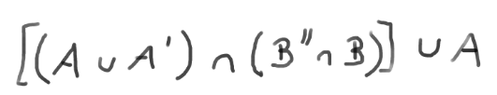

1. Using mathematical induction, prove that the sum of the first n odd numbers in **N** equals n2. This means for all n holds 1 + 3 + 5 …. + (2n-1) = n2

For example: for n=3 we have 1+3+5 = 9 , for n=4 we have 1+3+5+7=16 , and so on.

1. For A = {1,2,blue} compute the Cartesian product of A with itself.
2. For f : {-3,-2,-1,0,1,2,3} 🡪 **R** f(x) = x*x determine what the domain, co-domain and range are. Is the function injective, surjective or bijective. If it is bijective what is its reverse function?
3. Plot the graph of the function f(x) = 2 abs(x) - 1
4. Determine if the >= (larger or equal) and != (not equal) relations on R are reflexive, transitive or symmetric.
5. Define some equivalence relation on the set of all strings over {a,b,c,d,e}. What are the equivalence classes
6. Define some order relation on the set of strings.